


College of Electrical & Mechanical
Engineering, NUST

MECHATRONICS ENGINEERING

DATA STRUCTURES AND OBJECT-ORIENTED PROGRAMMING (EC-204)

PROJECT REPORT

GROUP MEMBERS:
Name: Unzila Zeb
Registration No. : 467557

Date of Submission: 25th December 2024

INTRODUCTION
The project is a server-based application designed to manage and control a network of bots. The server allows users to add and remove bots, send commands to control them, and retrieve data from them. This system facilitates seamless interaction with multiple bots, making it ideal for use cases that require autonomous operations or monitoring across a fleet of devices.
Purpose:
The primary purpose of this project is to provide a robust framework for managing bots and collecting data from them in a controlled environment. It allows for dynamic bot management, enabling users to:
1. Add and Remove Bots: The server can easily handle the addition and removal of bots, giving flexibility in managing the bot network.
2. Send Commands: Users can send commands to specific bots or broadcast commands to all active bots. This feature provides central control for executing instructions remotely.
3. Display Active Bots: The system provides an overview of all active bots, showing their current status and location, ensuring users can keep track of their operations.
4. Request Data: At any point, users can request the data collected by the bots, such as information on the terrain or environment the bots are interacting with.
5. Store Commands: All commands issued to the bots are logged, with individual and combined commands being stored in separate files for record-keeping and debugging purposes.
6. Unique Data Files per Bot: Each bot has its own dedicated data file that logs specific information related to that bot's activities, ensuring that no data is lost or overwritten.
This project is designed to provide a comprehensive tool for managing autonomous bots, with an emphasis on control, tracking, and data management.

ARCHITECTURE/BLOCK DIAGRAM

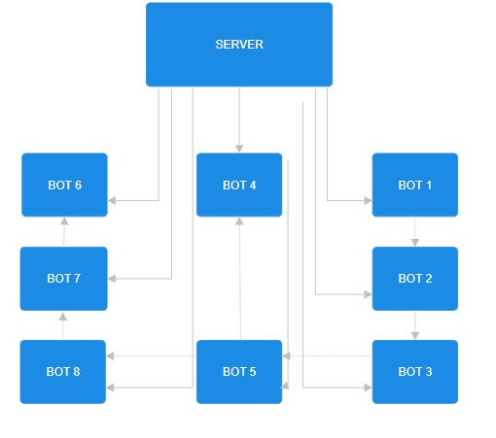

OUTPUT
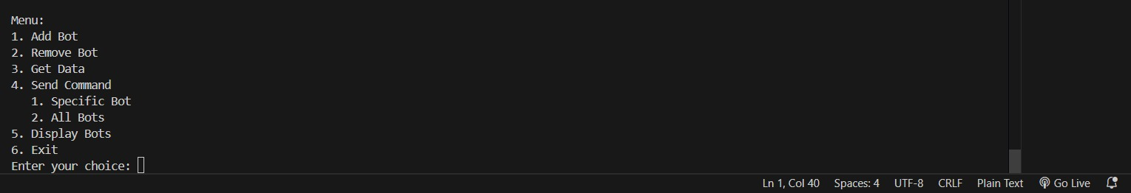
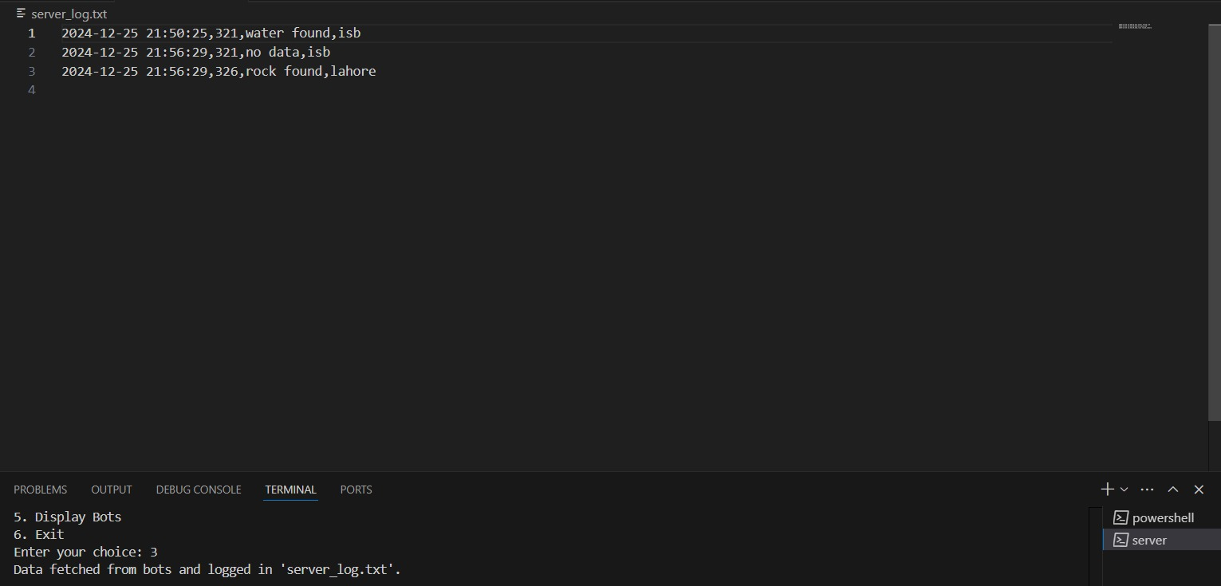
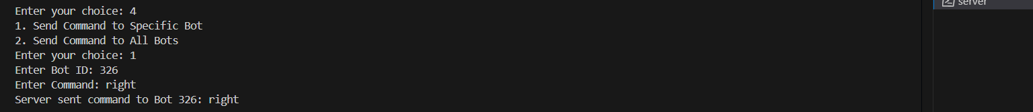

CONTRIBUTIONS
KHADIJA ASLAM | SYEDA MARYAM REHAN
Discussion of different ideas and final proposed idea | Discussion of different ideas and final proposed idea
Research | Research
Code editing and debugging | Code editing and debugging
Demo video | Code use instructions(readme file)
Report | Report

CONCLUSION
This project demonstrates the implementation of a robust server-based application for managing and controlling a network of autonomous bots. The system provides a comprehensive framework for dynamic bot management, command execution, and data collection, making it a valuable tool for applications requiring seamless interaction with multiple devices. Key features such as the ability to add and remove bots, send commands to specific or all bots, display active bot statuses, and retrieve bot-specific data files ensure efficient monitoring and control of bot networks.
An additional highlight of the project is the integration of AVL trees for managing bot data and operations. The use of AVL trees, a data structure not covered in class, demonstrates an innovative approach to ensuring efficient data organization and retrieval. By leveraging AVL trees, the project achieves optimized performance in handling dynamic bot management, which further enhances its scalability and responsiveness.
Moreover, this project showcases advanced concepts in server-client interaction, data management, and autonomous control, providing a strong foundation for further development and real-world applications.

